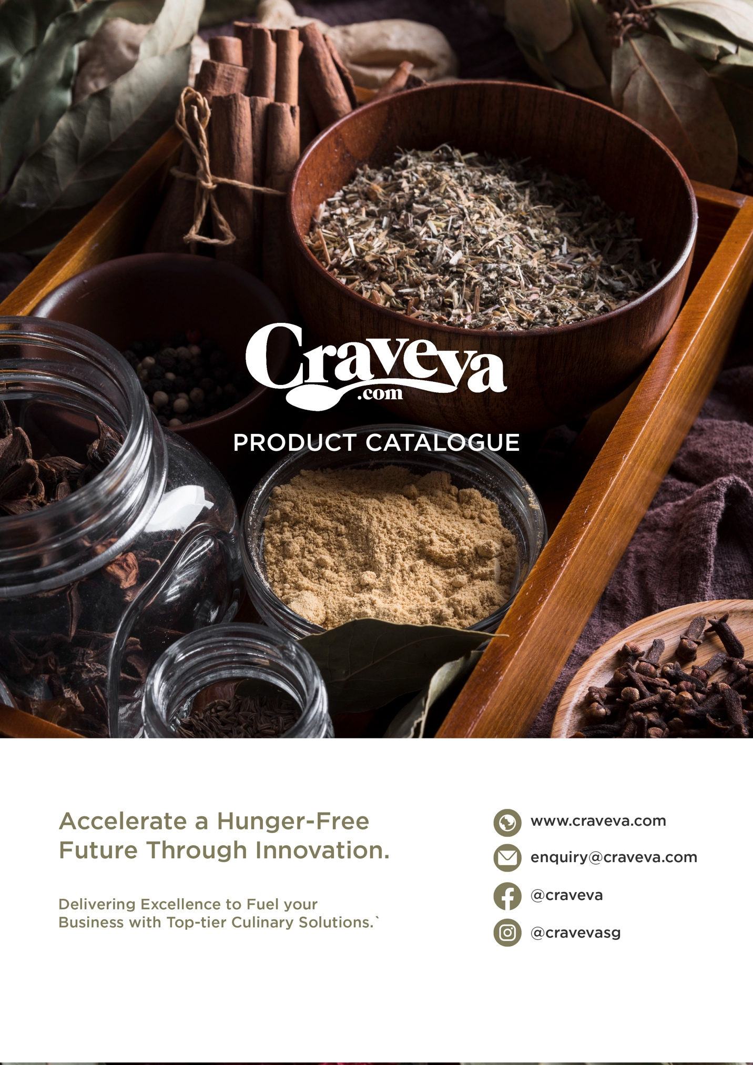

苗林食品 Miaolin Foods B2B AI智慧分銷平台規劃書

苗林食品 (Miaolin Foods) B2B AI智慧分銷平台規劃書
提交單位： CRAVEVA PTE LTD
提交對象： 苗林食品 (Miaolin Foods)
日期： 2025年12月
版本： v5.0 (全渠道整合與 AI 賦能版)

1. Executive Summary
This plan aims to create an "omnichannel B2B brand distribution management center" for Miaolin Foods. Given that Miaolin is a large importer that needs to manage multiple international agency brands and serve different levels of B2B clients (chain stores, distributors, and individual stores), we propose a solution based on Craveva AI Enterprise.本計畫採取務實的「分階段數位化」策略：
- Phase One (Start Immediately)： Establish a standardized "Daily File-Based Integration" mechanism. Without altering the existing Digiwin ERP and Salesforce architecture, immediately automate orders and manage complex pricing through intelligent import/export and automatic SKU conversion technologies.
- Phase Two (Future Planning)： Once the platform's operational data stabilizes, it will be upgraded to real-time API connectivity.

2. Core pain points and needs analysis (Key Challenges)
Based on your business scenario and current operations, we have identified the following five core challenges:
- Daily maintenance of complex B2B pricing: This requires managing multiple brands and a 5-tier pricing logic (from publicly listed prices to customer-specific contract prices). Due to fluctuations in raw material prices, it is essential to ensure that the latest pricing strategy in the ERP system is quickly synchronized to the platform every morning to avoid discrepancies in pricing.

- Order data format conversion (SKU Mapping)： Customers place orders in "units," but Dingxin ERP requires them to be recorded in "cartons." If the exported order reports are not converted, subsequent manual modifications will be time-consuming and prone to errors.
- Unified management of multiple brands： As an importer, you need to manage all the brands you represent through a single back-end system, allowing customers to make one-stop purchases while also facilitating the central office to centrally aggregate orders.

- Too many workers: Orders come from scattered and disorganized sources: Currently, orders come from multiple channels such as websites and Line groups, and the formats vary (text messages, screenshots, voice messages). Business assistants need to spend a lot of time manually sorting and confirming specifications and manually keying orders, which is inefficient and prone to missing orders.
- Multiple data sources make internal integration and analysis difficult: Sales data is scattered across Dingxin ERP, Salesforce, Google Workspace, and Line conversation logs. The lack of a unified "data platform" to integrate this heterogeneous data makes it difficult for management to grasp the true sales picture across brands in a timely manner.

3. Solution Architecture
This solution uses Craveva AI Enterprise as its core foundation and employs a modular stack to build Miaolin Foods' digital distribution hub. The architecture consists of three layers: the core operations layer, the smart pricing layer, and the AI-enabled layer.

3.1 Core Modules Configuration
To address the multi-brand management needs of importers, we selected the following enterprise-level modules as the system backbone.
- Supply Chain and Procurement Module (Supply Chain & Procurement)：
  - Multi-brand inventory center： Supports centralized management of product master files and inventory for multiple agency brands (such as Japanese flour and French butter), and supports batch number and expiration date management.
  - Virtual SKU Converter (Virtual SKU Mapper): It is responsible for automatically converting the "sales unit (Unit)" of front-end orders into the "inventory unit (Carton)" recognized by the ERP system to facilitate the transfer.
- Financial Management Module：
  - B2B Accounting Integration: Process invoices, credit notes, and tax rate calculations, and ensure that the exported financial data format is compatible with Dingxin ERP.
- Customer & Partner Management:
  - B2B Customer Portal: Provides a tiered account system, allowing customers at different levels (chain headquarters vs. franchise stores) to have corresponding purchasing authority and pricing visibility.
- Insights & Governance:
  - Data Platform: Aggregates heterogeneous data from ERP, Line, and Web, providing role-based access control (RBAC) and a visual war room.

3.2 Smart/Intelligent Pricing Engine
To address the extremely complex pricing system for seedlings, the system incorporates a 5-level priority coverage logic (override logic) to ensure pricing accuracy and contract compliance.
- Level 1： Base Price - The system's underlying suggested retail price for the product (MSRP)。
- Level 2： Public Price - [Level 1 Coverage]. Displayed to unlogged visitors, typically at a higher level to protect the distribution network. (Do not publicly display to unlogged visitors.)
- Level 3：Group Tier Price (Tier Pricing) - [Coverage Level 2]. General discounts (e.g., 10% off storewide) set for specific customer groups (e.g., Platinum Distributors, Food and Beverage Channels).
- Level 4：Exclusive Contract Price for Clients (Client-Specific Pricing) [★Highest Priority] - [Cover all lower layers].
  - Daily synchronization mechanism: Supports daily import of Excel updates from ERP. Locks in absolute prices for "specific customer (Client A) + specific product (SKU 001)" to ensure consistency with offline contracts.
- Level 5：Massive discount (Volume Discount) - - [Final Revision]. Based on the above prices, if the purchase quantity reaches a threshold (e.g., 10 packs/1 box), an additional discount or full-case price will be automatically triggered.
- (Not required: Do we need to add the cumulative purchase quantity reached within a specific period?)
- How to convert different batch numbers into carton prices: Testing the acceptance of Dingxin's system (currently, prices are manually selected when entering the order).
- How to convert different batch numbers into carton prices: Testing the acceptance of Dingxin's system (currently, prices are manually selected when entering the order).
- 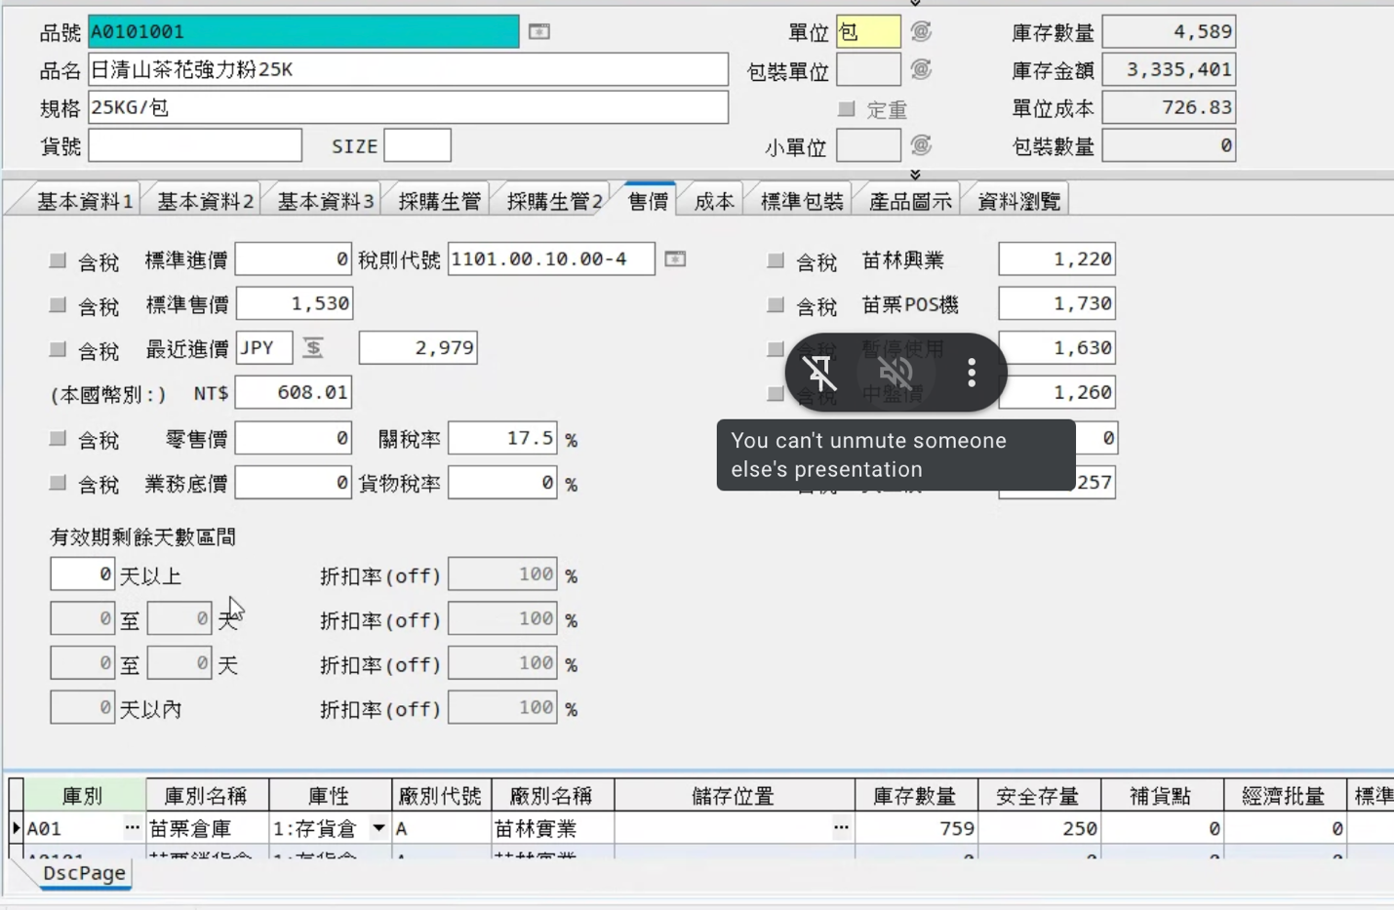
- Evaluation >> Phase 1: Use only standard price and customer order price on Line >> Special promotional methods will be used in Phase 2
- Export and import product information does not require images, only text.

3.3 (AI Capabilities)

By introducing Craveva's proprietary AI Agent technology, the passive order-taking system is upgraded into a proactive intelligent business assistant:

1. AI Procurement Assistant
- Application scenario: To solve the efficiency bottleneck of order taking via Line and text messages.
- Function：
  - Natural language ordering: A customer sends a message on Line saying "I want the same flour as last week, plus two boxes of butter." The AI ​​can automatically interpret the intent, compare it with historical orders, and generate a standardized shopping cart link for the customer to confirm.
  - Mistake prevention mechanism: If the customer's instructions are ambiguous (such as only saying "flour" but there are three specifications), the AI ​​will automatically ask for confirmation to reduce errors.
  - It's necessary to determine whether there's stock available, but not to tell the customer the actual inventory quantity.

2. AI Sales Agent (AI Sales Strategies)
- Application scenarios： 24/7 Product Consulting and Business Development。
- Function：
  - Product Knowledge Base： Learn the specifications (PDF) of all the brands that Miaolin represents. When customers ask, "What is the fat content of this fresh cream?" or "Where is it made?", the AI ​​can answer instantly and accurately.
  - Related Recommendations： Based on the customer's browsing history, we proactively recommend suitable complementary products.

3. (AI Data Analysis - For Internal Management)
- Application scenarios: Cross-channel and cross-brand operational insights.
- Function：
  - Omnichannel data integration: Cross-analyze ERP shipping data, integrable channels, and Line/Web order data.
  - Proactive insights: For example, generating weekly reports to highlight abnormal trends. For example: "Brand A's inventory turnover rate dropped by 15% this week, promotion recommended" or "Customer B has not placed an order for two consecutive weeks (churn warning)".

3.4 Customized front-end integration architecture (Headless Commerce Integration)
This solution supports Miaolin Foods' highly customized needs for brand image and shopping experience.「Headless Commerce (無頭電商)」. Architecture. This means that Crave will serve as a powerful backend digital engine, seamlessly integrating with the frontend web pages developed by your designated design team through standardized APIs.
This "front-end and back-end separation" model ensures absolute design freedom while retaining Craveva's powerful B2B computing core.

A. System division of labor boundaries
- Frontend Layer - Designed by an external team：
  - Responsible for all UI/UX design, visual presentation, and RWD responsive web development.
  - Responsible for creating a unique shopping experience that aligns with Miaolin's brand aesthetic.
- 後端邏輯層 (Backend Layer) - handled by Craveva:：
  - Product and Inventory Hub: Provides product information, specifications, and real-time inventory data.
  - Intelligent Pricing Calculation: When the front-end client inquires about a price, Craveva instantly returns the client's accurate contract price based on a "5-level logic," ensuring the front-end client doesn't need to rewrite complex pricing formulas.
  - AI Business Assistant Core: Provides API interfaces for AI dialogue and recommendation engines.

B. API Integration Process (Data Flow)

We will provide the complete Storefront API documentation for the design team, covering the following core interactions:
- Product Synchronization (Catalog API): The front-end calls the API to retrieve the product list, images, specifications, and current available inventory.
- Real-time Pricing API: When a B2B customer logs into the front end, the front end sends Client_ID and Product_ID via API, and Craveva returns the calculated Final_Price (including the Level 4 contract price).
- Order writing (Order API): After the customer checks out at the front end, the order information is written to Craveva via API, and Craveva then performs the subsequent "virtual SKU transcoding" and "ERP export" processes.
- AI Widget Embedding: Embed the AI ​​Sales Agent in the form of a "Chat Widget" or API to provide 24/7 consultation services.

4. Daily Operations SOP (Daily Operational Workflow)
To support the "daily file exchange" model, we have designed a standardized daily workflow:
- Morning Sync - 08:30 AM：
  - The administrator exports the daily inventory list and customer price list from the Dingxin ERP system.
  - This is then uploaded to Craveva, where the system automatically updates the total available inventory and Level 4 exclusive prices.
- Daily Interchange Orders (Trading Hours)：
  - Line/Text： AI Purchasing assistant automatically processes text orders。
  - Web Portal： Customers can instantly see exclusive prices when they log in to the website and place an order.
- Evening Export – by 11:00 AM the following day at the latest: (To be confirmed)
  - Administrators can download the daily order summary table with one click.。
  - Key Action: At this point, the system performs "virtual SKU mapping," automatically converting the "single item" in the order into the "box number (Box SKU)" required by the ERP system.
  - Import the files into Dingxin ERP to complete the daily accounting.
- (Processing mode for duplicate order imports)

5. Implementation Roadmap
The first phase of this project is expected to be completed and launched in 12-14 weeks (excluding front-end design and integration).
- Phase 1：Infrastructure and Data Cleaning (Weeks 1-4)
  - Establish a multi-brand product database。
  - Key task: Define the import template (Excel Template) and SKU conversion rules for Dingxin ERP。
- Phase 2：AI Training and Pricing Configuration (Weeks 5-8)
  - Train the AI ​​to recognize common phrases in Line orders (e.g., "add to cart," "as usual").
  - Set up a 5-tier pricing logic and test the daily inflow process
- Phase 3：Omnichannel process drill (Weeks 9-11)
  - Simulates the complete closed loop of "ERP export -> Craveva order acceptance (including Line/Web) -> transcoding -> ERP import" to ensure zero data error.
- Phase 4：UAT and Official Launch (Weeks 12-14)
  - Official switchover, employee training, and AI assistant launch。

6. Investment Proposal
Given Miaolin's needs as a large importer, we recommend the Craveva Enterprise Plan (Customized Enterprise Version):

A. (Project Implementation Fee)
- Project： One-time fee。
- Contents：
  - Dingxin ERP Format Converter (SKU Mapping Module) Development
  - Line order AI analysis and integration module.。
  - Daily pricing import into automated logic configuration
  - Custom Frontend API Integration Support (Custom Frontend API Support)：
    - Provide Storefront API technical documentation。
    - Technical coordination meetings with external design teams。
    - Assist with API connection testing (Sandbox environment)。
  - Professional onsite service and data cleaning assistance。

B. System Subscription Fee
- Project： Annual or monthly recurring expenses (Recurring Fee)。
- Contents：
  - Unlimited expanded benefits: Unlimited users, access to all modules.
- Note: The subscription includes full access to the Craveva platform, including the core ERP module, CRM, HR, project management, and new modules to be released in the future. Enterprises can freely enable these modules as needed.
  - Cloud hosting and maintenance： Ensure 99.9% system availability and secure data backup.
  - Future Major Upgrades: During the subscription period, Miao Lin will enjoy all feature updates, security patches, and performance optimizations for the Craveva main system free of charge, ensuring that the platform technology never becomes outdated.

C. AI Usage Fee
- Billing model: Pay-per-Token model.
- Note: For high-volume AI computations (Line dialogue parsing, large-scale data analysis, sales knowledge Q&A), a token-based billing model is adopted, where payment is based on actual usage.
- Advantages: Enterprises can precisely control AI costs, paying only for the actual value generated, and have flexible scalability.

7. Conclusion and Next Steps
This solution will free Miaolin Foods from tedious manual order taking and quotation maintenance. Through Craveva's intelligent transformation and omnichannel AI assistant, your company will immediately gain a powerful distribution platform capable of handling complex B2B logic, integrating Line orders, and seamlessly collaborating with your existing ERP system.
Recommended next steps:：

7.1 Administrative & Commercial process
- [v ] Sign a Confidentiality Agreement (NDA): Before gaining in-depth access to your ERP data and customer list, we recommend signing an NDA to protect Miaolin Food's trade secrets.
- [ ] Confirm requirements, pricing, and contract scope: Confirm the requirements, subscription modules, and customized development scope in the above "Investment Plan" and complete the contract signing.

7.2 Technical Preparation
- [ ] Provides a standard import template for Dingxin ERP (Excel/CSV)：(To be confirmed)
  - Objective: To provide Craveva's technical team with a "virtual SKU converter".
  - Content: Must include the standard order import format, especially indicating which fields are required (e.g., customer code, inventory number, warehouse code).
- [ v] Provide existing product master files and inventory sheet templates：
  - Purpose: To test the "Daily Morning Sync" process.。
  - Contents: Includes product name, SKU code (per piece/box), batch number format, etc.。
- [ ] AI Training corpus collection：
  - Line conversation logs: Provide approximately 50-100 de-identified "real customer order messages" (screenshots or text files) to train the AI ​​purchasing assistant to recognize phrases such as "as usual" and "additional".
  - (Is it possible to use a line API to scrape historical messages?)
  - Product Knowledge Base: Provides product specifications, DMs, or FAQs (PDF/Word) for each brand it represents, which can be used to train AI sales personnel to answer product-related questions.

7.3 Project Coordination Launch
- [ ] Arrange a tripartite technology kickoff meeting:
  - Participants: Miao Lin Project Manager + Website Designer Zheng Zhi + Craveva Architect.。
  - Agend：
    - Deliver the Storefront API technical documentation.。
    - Confirm the data integration process between the front-end website and the Craveva back-end (login verification, price inquiry, order placement).
    - Delineating the boundaries of error correction responsibility。
- [ ] SKU Conversion Logic Defining Workshop (Mapping Workshop):
  - Participants: Miao Linye Assistant/Purchasing Manager + Craveva Data Engineer.
  - Content: Review the major brands one by one to identify which products need to be subject to "single-item transfer" rules (e.g., A flour is 10 bags/box, B butter is 12 cans/box).



